**MVC .Net - Fundamentals**

1. **What is Program?**

* A computer program is a collection of instructions that performs a specific task when executed by a computer.
* A computer program is usually written in a programming language.
* Program Can be written in higher level programming languages that human can understand.
* Those programs are translated to computer understandable languages.
* Task will be done by special tool called compiler

1. **What are Tokens?**

* C program consists of various tokens.
* Ex. - Keyword, Identifier, Constant, Literal, Operators, or a Symbol.

1. **Data Types**

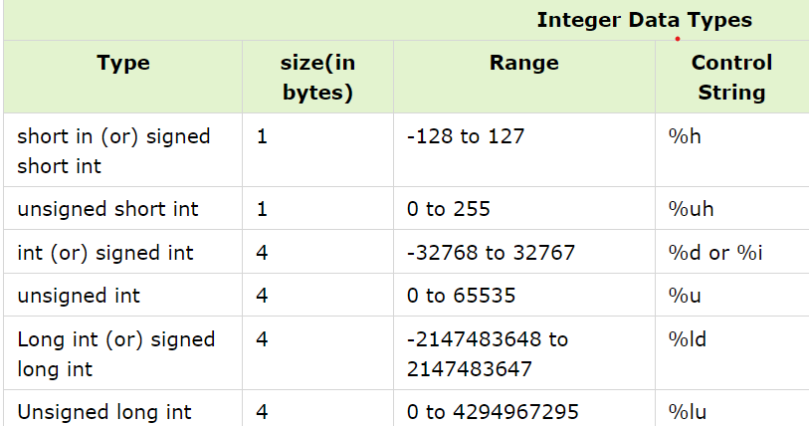

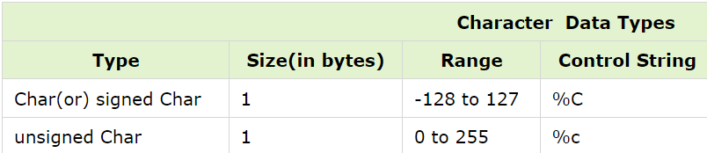

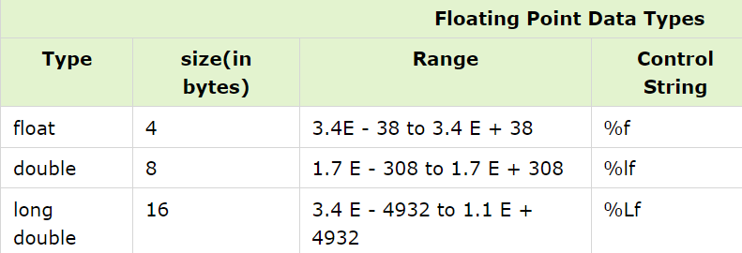

1. **Identifiers**

* Identifier refers to name given to entities such as variables, functions, structures etc.
* Identifier must be unique. They are created to give unique name to a entity to identify it during the execution of the program.
* Rules for writing an identifier:

1. A valid identifier can have letters (both uppercase and lowercase letters), digits and underscores.
2. The first letter of an identifier should be either a letter or an underscore. However, it is discouraged to start an identifier name with an underscore.
3. There is no rule on length of an identifier. However, the first 31 characters of identifiers are discriminated by the compiler.
4. **Keywords**

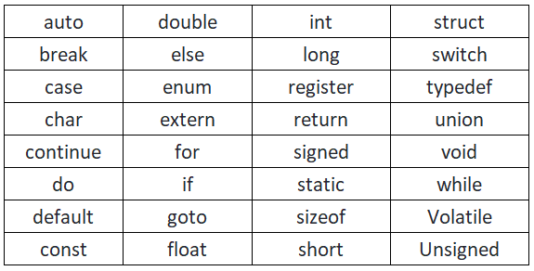

1. **Operators**

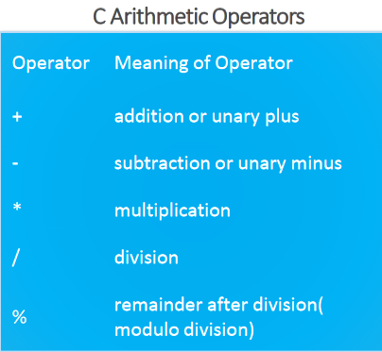 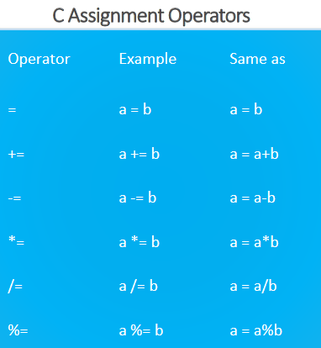

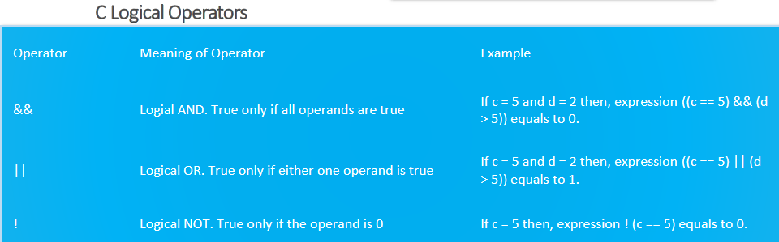 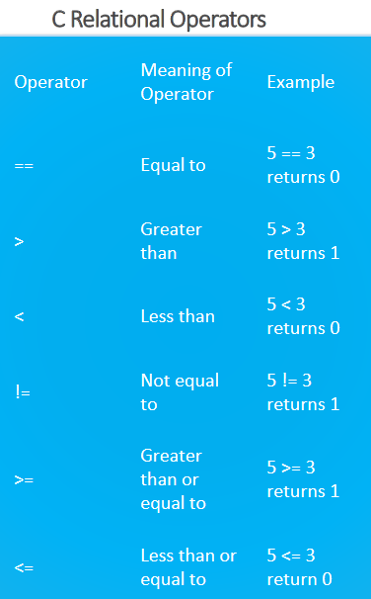

1. **What is SDLC? Explain each phase of SDLC**

* The Software Development Life Cycle (SDLC) refers to a methodology with clearly defined processes for creating high-quality software. In detail, the SDLC methodology focuses on the following phases of software development:

1. Requirement Gathering
2. Analysis & SRS
3. Designing
4. Implementation (Coding)
5. Testing
6. Maintenance
7. **Requirement collection**

* Phase of collecting requirements from client
* Will be done by business analyst of company
* He will create questioner, in which put answers from client

1. **Analysis & SRS (Software Requirement Specification)**

* Collected requirements will be analyzed for time limit, budget and market trade
* Will be filtered and SRS will be created as result
* Will be discussed with client
* Based on requirements users, their activities and flow of data, modules will be defined
* Will be done by system analyst
* Based on diagrams all will be done
* Main diagrams are use-case, DFD and flow charts

1. **Designing**

* The Design document should reference what you are going to build to meet the requirements, and not how it can include pseudo code but shouldn’t contain actual code functionality.
* Design elements describe the desired software features in detail, and generally include functional hierarchy diagrams, screen layout diagrams, tables of business rules, business process diagrams, pseudo code, and a complete entity-relationship diagram with a full data dictionary.
* These design elements are intended to describe the software in sufficient detail that skilled programmers may develop the software with minimal additional input. At this phase the test plans are developed.

1. **Implementation (Coding)**

* To launch the coding phase, develop a shell program that is then put under some form of version control.
* This phase includes the set up of a development environment, and use of an enhanced editor for syntax checking.

1. **Testing**

* Each developer insures that their code runs without warnings or errors and produces the expected results.
* The code is tested at various levels in software testing. Unit, system and user acceptance tasting’s are often performed. This is a grey area as many different opinions exist as to what the stages of testing are and how much if any iteration occurs.

1. **Maintenance**

* User’s guides and training are developed to reflect any new functionality and changes which need to be identified to the production staff.
* Any changes needed to operations and/or maintenance need to be addressed.
* Every run in production needs to be verified. Any problems with production need to be addressed immediately.
* A Change Request system may be set up to allow for feedback for enhancements.

1. **What is DFD?**

* DFD – Data Flow Diagrams
* Graphical representation of flow of data inside application can also be used for visualization and data processing
* DFD elements are..
* **External Entity**
* Can be user or external system that performs some process or activity in project Symbolized with rectangle
* **Process**
* Work or action taken on incoming data to produce output
* Each process must have input and output
* **Data Flow**
* Can be used to show input and output of data
* **Data Store**
* Can be used to show database tables
* Only process may connect data stores
* There can be two or more process sharing same data store

1. **What is Flow chart?**

* Used to show algorithm or process
* Can give step by step solution to the problem
* The first flow chart was made by John Von Newman in 1945
* Pictorial view of process
* Helpful for beginner and programmers
* Flowcharts are generally drawn in the early stages of formulating computer solutions.
* Flowcharts facilitate communication between programmers and business people.
* These flowcharts play a vital role in the programming of a problem and are quite helpful in understanding the logic of complicated and lengthy problems.
* Once the flowchart is drawn, it becomes easy to write the program in any high level language.
* Often we see how flowcharts are helpful in explaining the program to others.
* Hence, it is correct to say that a flowchart is a must for the better documentation of a complex Program.